**P3 & M1**

*For P3, describe the potential barriers to communication. For M1, learners can consider the barriers they have identified for P3 and explain what can be used to reduce the impact of these. Explain how the mechanism can be used and why it may work.*

Firstly, I am going to name the types of communication that is available to people:

* Documents
* Presentation
* Email
* Blogs
* Videos
* Verbal
* Visual

[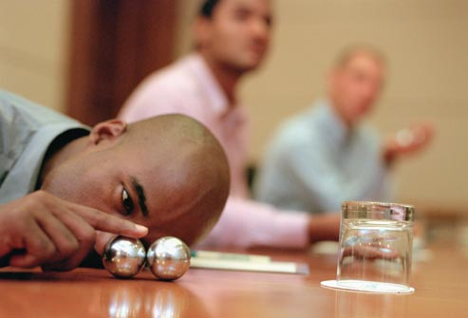](http://www.google.co.uk/url?sa=i&rct=j&q=&esrc=s&frm=1&source=images&cd=&cad=rja&docid=qGwE-cyuZWYEXM&tbnid=FbAQIm5XU_45OM:&ved=0CAUQjRw&url=http://cognitivetherapysf.com/adult-adhd-relationships/&ei=j5mgUsTnPNGl0wXo_IDIDw&bvm=bv.57155469,d.ZGU&psig=AFQjCNG_LYB2OpLpGGHOLMttcMDsQ6w_eQ&ust=1386343154026344)These are the main ones. The barriers to communication could be some **distractions, lack of concentration and background noises** whilst someone is trying to speak to each other. If you are trying to present yourself in an audience, you will need to be clear and concise of what you are trying to address to your audience. You will need to prevent any barriers of communication as much as possible. For example, if I am trying to speak and they is someone outside trying to make funny faces at me, I will get distracted and not be focus on what I am saying. Therefore, the audience will not understand what I am trying to say. Concentration needs to be accurate because it may hinder your audience. Background noises is important because if you are in an interview and you keep hearing noises and are not concentrated at what the interviewer is telling you, you will be unsuccessful. The first barrier that I mentioned is distractions, lack of concentration and background noises. To prevent this from happening, they would need to practice repeatedly to get it correct. They could even get someone to distract the person whilst presenting to see if he gets distracted. Once they know it is perfect, they will continue what they have said without getting distracted by the noise.

All of these points made, tie in with each other because they all link in with each other.

[](http://www.google.co.uk/url?sa=i&rct=j&q=&esrc=s&frm=1&source=images&cd=&cad=rja&docid=OmH0P5q_SpIfcM&tbnid=2_F5-Y8Bkrq-sM:&ved=&url=http://www.aboutleaders.com/are-you-an-igniter-or-an-extinguisher/&ei=NZmgUt3bKJL07Aac8ICIAg&bvm=bv.57155469,d.ZGU&psig=AFQjCNFh4awcLEPAmYDp_cMDO5Xf12g3aA&ust=1386343093901661)Another barrier could be if the **language spoken** is different from each other. It could be difficult to understand what another person is trying to say when he or she cannot speak the language properly. For example, if a new student has arrived in your college and he or she wants know where her class is, they will need to speak the same and fluent language to communicate well. This may be a barrier as they will not be able to communicate well with each other. Because of not knowing the language, they will not be able to find out information on their query. This barrier could follow it on to **typing an email**, as well because if you send an email to someone that you do not know, with your bad English the person would not know what you have said to him or her. As this follows on to typing an email and language spoken. The email should be proofread every time for the communication to be successful. This could work because if you proofread your work, they can be errors that are identified and are altered. If there is any errors in the email, the other user will get confused and assume he has said something else. Some could type in capitals so to prevent this they need to type lowercase so the other user does not assume that you are shouting. If language spoken cannot speak English or the language they are trying to communicate, they needs to go to English classes to learn English. Therefore, they can be able to communicate much better.

**The method** of communication could be very important. Whilst trying to communicate with little children, you will need to use vocabulary that they understand. For example, if you are trying to say ‘Go and close the door’ but the toddler got a confused face, he would not follow that command. You will need to show him and then he will follow and understand what you just said. The communication tool varies with different aged of people. To prevent this from happening, you can show them videos or diagrams of what you are trying to say. This way, visually, they would understand what you are trying to say. If you are using complex words, use simple words so they understand. Also, speak slowly so they can understand what you are trying to say.

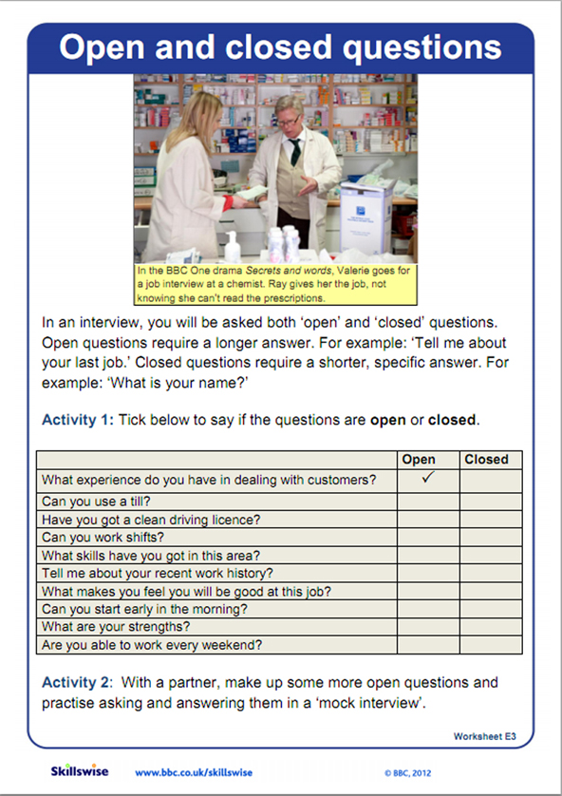**Open and closed** questions could be a barrier for communication. Open question is expected an answer such as ‘How are you today?’ and the answer ‘I am fine, thanks.’ Closed question is a yes or no answer. For example, ‘Would you like a drink?’ ‘No thanks.’ It is difficult to find out in a normal conversation whether you have been asked an open or closed question. If the person never understood either if it is an open or closed question, they would not be any answer or would be confused about it. It also depends on the chosen topic that the both students are talking. If they are talking about a topic that one person feels uncomfortable or has a ‘history’ against it, they would feel nervous talking about the subject. They would not be able to communicate with the other person or they would just be quiet. If you get confused with both of the question, firstly, you need to understand which type of question they said.

Another barrier could be confidence issue or depending who they are talking too. If they are presenting a presentation to another person in front of a crowd, they would be nervous and not that confident to speak out in front of people. However, it may be just the person they are speaking to they are not confident enough to speak in front of the person e.g. parents, teacher, police. To get their confidence better, they would need to practice a lot for them to be comfortable in front of a crowd. This will be beneficial in the future because if they need to work and they are asked to present in a crowd they do not know, they would be praised for the work. If you are trying to promote to a company your product, the presentation needs to be perfect in order for them to like your product; if you were shy, they would not consider buying your product.

